PRINCE2

Projects In Controlled Environments

**Processes**

**Themes**

**Principles**

Measured as

Enable

Deliver

Outcomes

Benefits

Projects

Products

**7 Principles:**

1. Continued business justification

**Benefit > Risk + Cost**

1. Learn from experience

To do better by **reviewing Previous Projects**

1. Defined Roles & Responsibilities

Project Board

Users(Soldiers)

Business Stakeholders(Taxpayers)

Suppliers(Mossad & Military)

1. Manage by stages

Project board **delegates authority** for managing each stage to the **project manager**, who then **manages day-by-day using a detailed stage plan**. The **project board** **monitors progress by reviewing a higher-level project plan**, which is updated at the end of each stage.

1. Manage by exception

When the project board decides to proceed to the next stage, they delegate authority to the project manager by **setting tolerances for cost, time, quality, scope, risks and benefits**.

1. Focus on products

Agree which products should be delivered, including the quality expected. The sum total of the products to be delivered is called **the scope of the project**. **The scope must be agreed between the major stakeholders** as early as possible. Their agreement forms **the basis of planning and status reporting** throughout the project.

1. Tailor to the project environment

No two projects are the same.

More **risk, project complexity, project size, project importance**. => More **monitoring, reporting and control**

**Theme**

1. Business Case Theme

**Benefit > Risk + Cost**

1. Organization Theme

**Who will be responsible for** making decisions, committing resources, and monitoring and reporting throughout the project.

The **project board** takes the key decisions on the project

whilst delegating day to day management of the stage to **the project manager**.

**Team managers** are responsible for delivering products agreed with the project manager.

**Project support** is there to assist project and team managers in their work.

**The project assurance role** assures the board that project is being conducted properly.

**Change authority** takes decisions about whether to implement changes on the project.

1. Quality Theme

It focuses on **which products** ought to be delivered by the project and **the level of quality expected for each product**.

1. Plans Theme

It focuses **on the steps required to produce plans**. The plans address how the products ought to be delivered, how much they will **cost** and how much **time** is required to deliver them. Plans form **the basis on monitoring and control**.

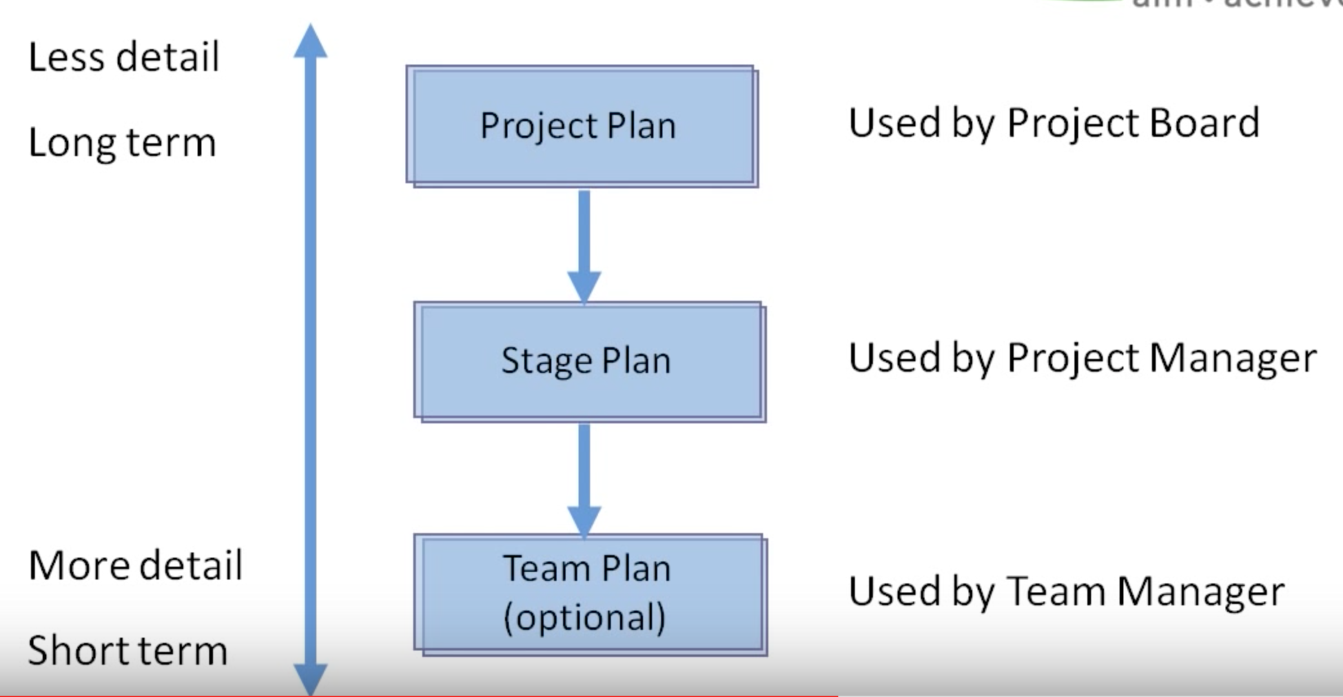

1. Risk Theme

**How to identity, assess, plan, implement and report risks** during the project.

A risk is an event that “may” occur in the future, and if it occurs, will affect the achievement of the project’s objectives.

1. Change Theme

It focuses on how the project management team assesses and makes decision about: general concerns or problems or requests to change any of the project products**. Changes must be assessed for their impact before decision to implement them can be taken.**

1. Progress Theme

It focuses on **the reporting activities that will be necessary for each level of project management team to keep a higher level of management informed about progress.**

Thus, it helps to ensure that decisions are taken in a timely and informed manner. Progress is reported against the agreed baselines. For example, an approved plan is a baseline. **Monitoring progress allows the project board to decide whether to continue with the project or to close it prematurely.**

**Processes**

1. **SU** Starting up a project

Do we have **a viable and worthwhile project?** This process occurs before a project is initiated. It is regarded as a pre-project process.

1. **DP** Directing a project (Board)

**It requires the board to decide whether the project has continued business justification**. If it does, they will commit the resources necessary for the next stage. The board also monitors progress, via report from project manager, and makes decisions about changes, exceptions and risks.

1. **IP** Initiating a project (Project manager)

**The firm foundations for the project** are established.

1. **CS** Controlling a stage (Project manager)

It describes the activities that the project manager must perform, in order to **allocate work** to teams, **monitor progress**, **manage issues in risks, report progress to the board** and **ensure the stage remains within its tolerance**.

1. **MP** Managing product delivery (Project manager)

During this process, the work allocated by the project manager is carried out. It is when all of the specialist products are designed, built and checked **to ensure that they conform to their requirements.**

1. **SB** Managing a stage boundary (Project manager)

Managing a stage boundary is performed by the project manager **at the end of each stage, except the final stage.**

1. **CP** Closing a project (Project manager)

Closing a project is performed by project manager at the end of the final stage of the project. During this process, acceptance of the project’s products is obtained from users and operational teams. The products are then handed over to users. It is also when the project manager will report on the achievements of the project, and any follow-on actions that will be required after the project is closed. Following this process, the project board authorises the closure of the project, after which time on more work is done on the project. All members of the project management team are then relieved of their responsibilities.

Summary:

PRINCE2 ensures that **the right information** is made available at **the right time**, so that **the right people** can make **the right decisions**.

Implementing PRINCE2 can **greatly increase the chances of delivering a project successfully on time, within budget and to the level of quality expected.**